15/4/26-
LAB DAY2

EXPERIMENT 1:
Code:
def first_palindrome(words):
for word in words:
if word == word[::-1]:
return word
return ""

print(first_palindrome(["abc","car","ada","racecar","cool"]))

OUTPUT:

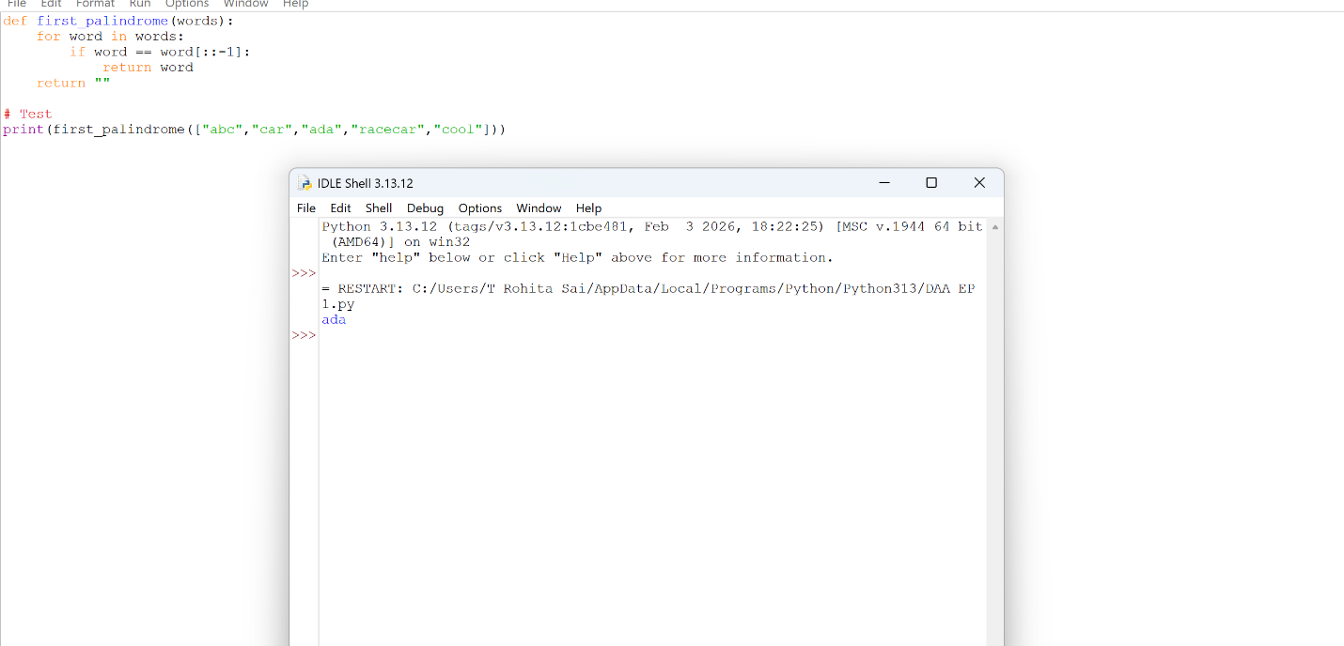
EXPERIMENT 2:
CODE:
def find_counts(nums1, nums2):
set1, set2 = set(nums1), set(nums2)

answer1 = sum(1 for x in nums1 if x in set2)
answer2 = sum(1 for x in nums2 if x in set1)

return [answer1, answer2]
print(find_counts([2,3,2], [1,2]))
OUTPUT:

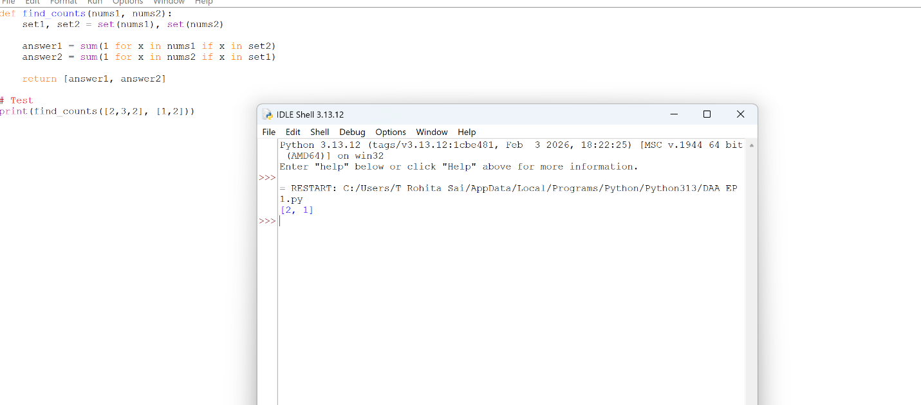

EXPERIMENT 3:
CODE:
def sum_counts(nums):
n = len(nums)
total = 0
for i in range(n):
s = set()
for j in range(i, n):
s.add(nums[j])
total += len(s) **
return total
print(sum_counts([1,2,1]))
OUTPUT: 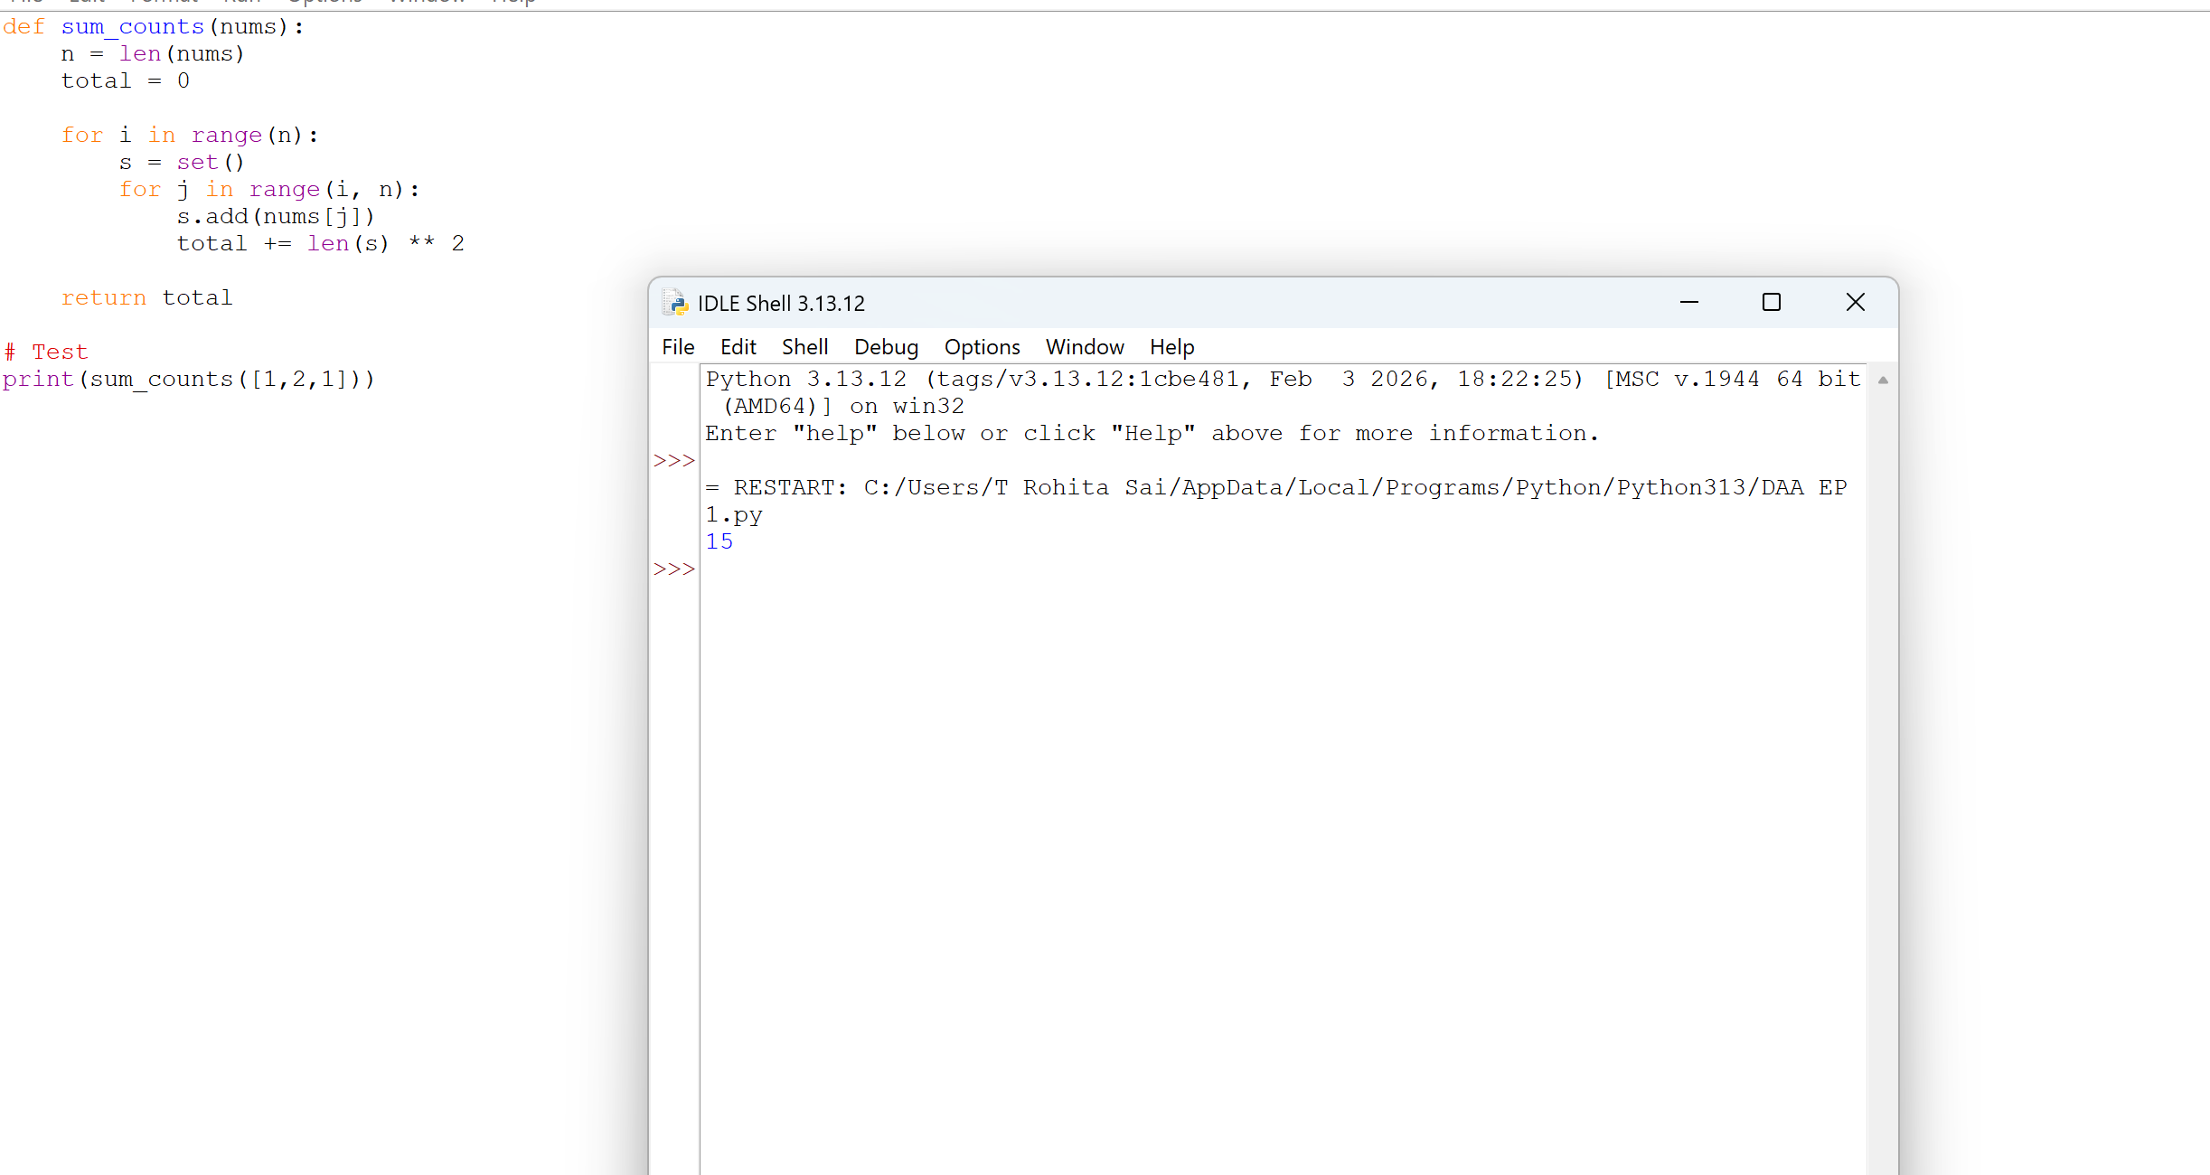

EXPERIMENT 4
CODE:
def count_pairs(nums, k):
n = len(nums)
count = 0
for i in range(n):
for j in range(i+1, n):
if nums[i] == nums[j] and (i * j) % k == 0:
count += 1
return count
print(count_pairs([3,1,2,2,2,1,3], 2))
OUTPUT:

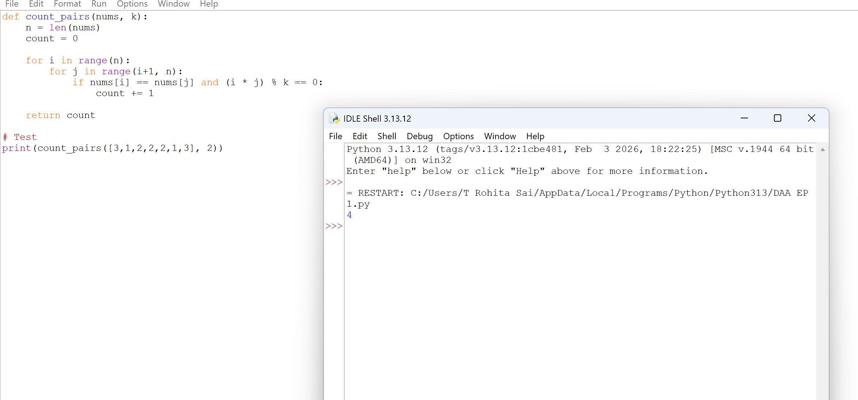

EXPERIMENT 5
CODE:
def find_max(arr):
if not arr:
return None
max_val = arr[0]
for num in arr:
if num > max_val:
max_val = num

return max_value
print(find_max([1,2,3,4,5]))
OUTPUT:
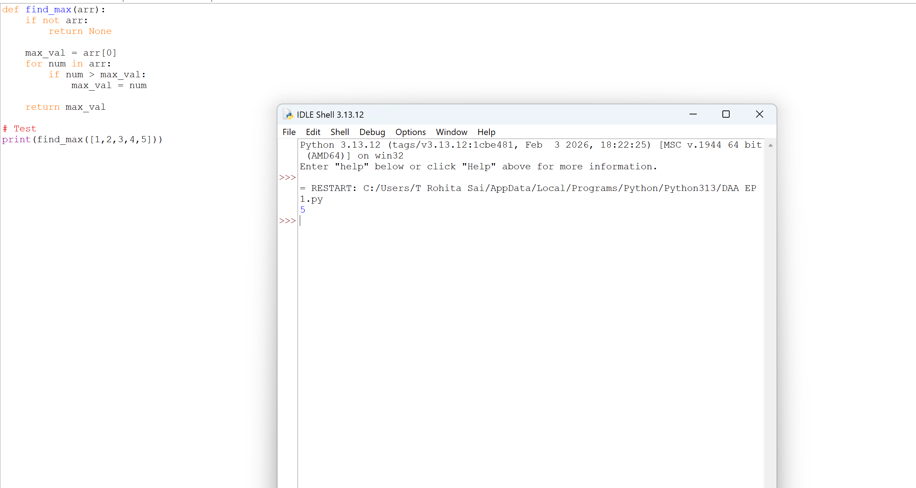
EXPERIMENT 6
CODE:
def sort_and_find_max(arr):
if not arr:
return None

arr.sort() # efficient built-in (TimSort)
return arr[-1]

# Test
print(sort_and_find_max([3,1,5,2]))
OUTPUT:

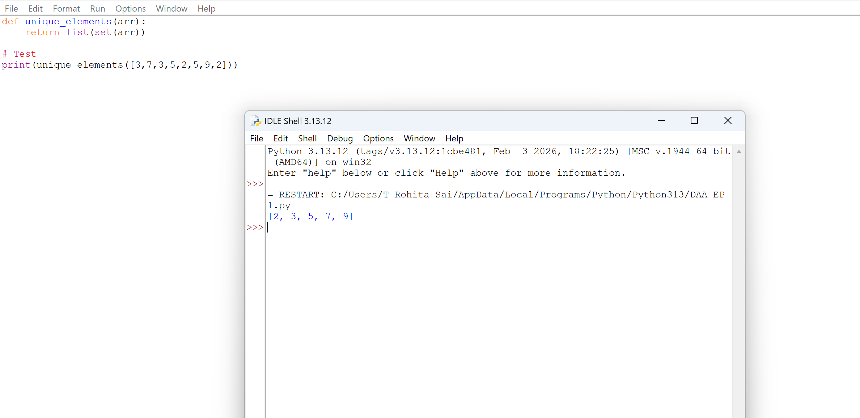

EXPERIMENT 7:
CODE:
def unique_elements(arr):
return list(set(arr))
# Test
print(unique_elements([3,7,3,5,2,5,9,2]))
OUTPUT:

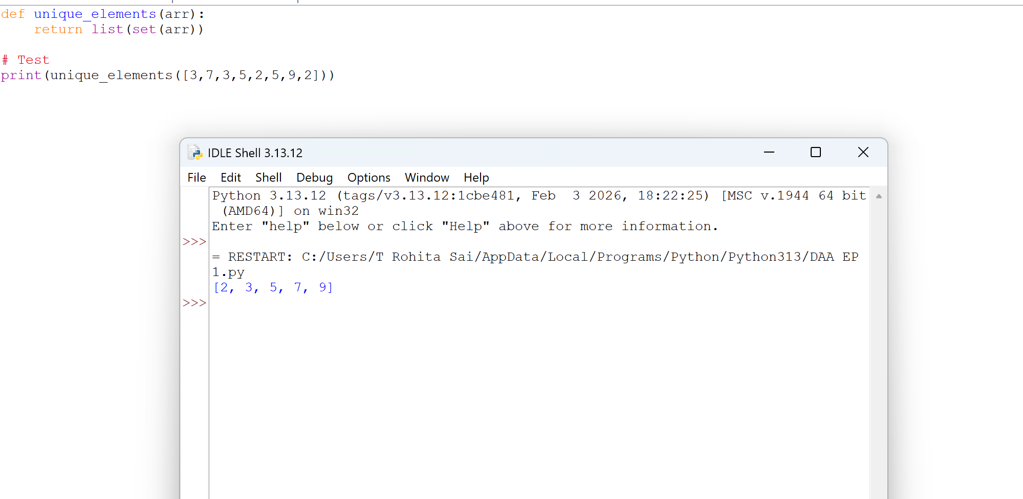

EXPERIMENT 8
CODE:
def bubble_sort(arr):
n = len(arr)

for i in range(n):
for j in range(0, n-i-1):
if arr[j] > arr[j+1]:
arr[j], arr[j+1] = arr[j+1], arr[j]
return arr

print(bubble_sort([5,3,2,1,4]))


OUTPUT:

EXPERIMENT 9:
CODE:
def binary_search(arr, key):
arr.sort() # ensure sorted
low, high = 0, len(arr) - 1

while low <= high:
mid = (low + high) // 2

if arr[mid] == key:
return f"Element {key} found at position {mid}"
elif arr[mid] < key:
low = mid + 1
else:
high = mid - 1

return f"Element {key} not found"

# Test
print(binary_search([3,4,6,-9,10,8,9,30], 10))

OUTPUT:

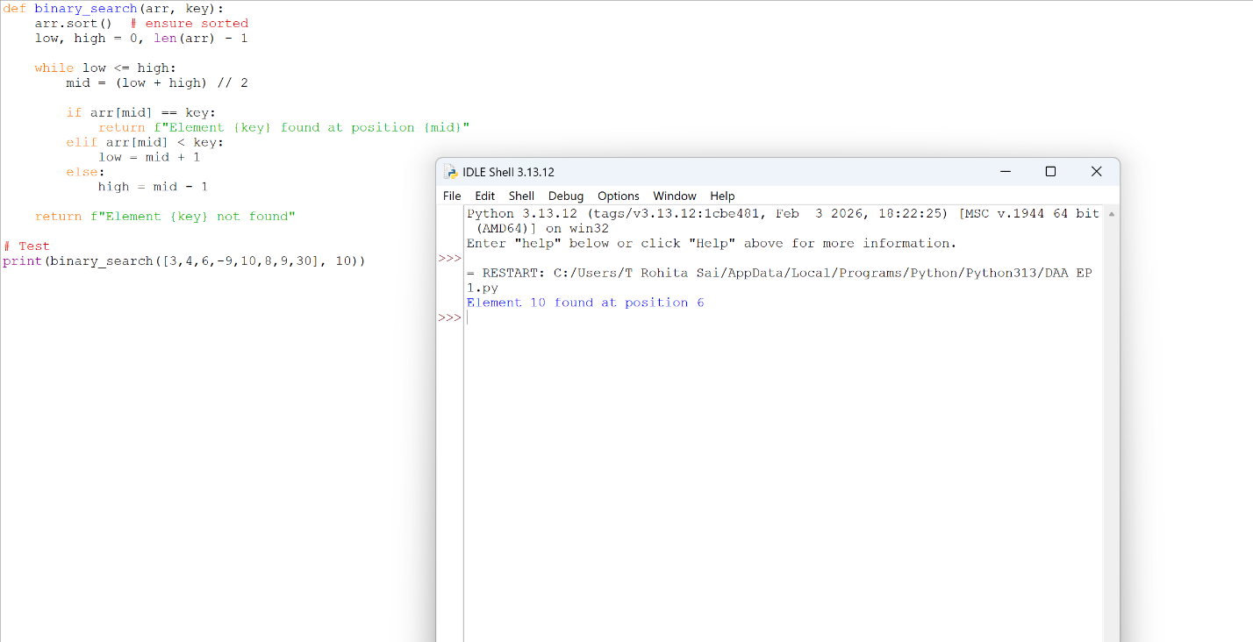

EXPERIMENT 10
CODE:
def merge_sort(arr):
if len(arr) <= 1:
return arr

mid = len(arr) // 2
left = merge_sort(arr[:mid])
right = merge_sort(arr[mid:])

return merge(left, right)

def merge(left, right):
result = []
i = j = 0

while i < len(left) and j < len(right):
if left[i] < right[j]:
result.append(left[i])
i += 1
else:
result.append(right[j])
j += 1

result.extend(left[i:])
result.extend(right[j:])

return result

# Test
print(merge_sort([5,2,3,1]))
OUTPUT:

